Department of Livestock production

Management of Non ruminants

LP

Assignment

Name:- S.T.Abeysinghe

Reg Number:-18AGA1654

Date of Submission:-01/06/2022

Select any poultry breed and prepare an assignment describing their origin, phenotypic and production characteristics and utility.

**Leghorn Poultry Breed**

Leghorn chicken is a Mediterranean chicken breed which is small, spritely, noisy bird with great style. Leghorns like to move. They are good foragers and can often glean much of their diet from ranging over fields and barnyards. Leghorns are capable of considerable flight and often roost in trees if given the opportunity.

**Origin**

The origins of the Leghorn are not clear; it appears to derive from light breeds originating in rural Tuscany in Northern Italy near the port for its namesake, Leghorn. The ancestors of this fowl are not known. The name comes from Leghorn, the traditional “anglicisation” of “Livorno” in 1865. But before that time they were initially called “Italians”. Leghorn chickens were first exported to North America. The Leghorn arrived America in 1828 by Captain Gates form the port city of Livorno in Tuscan. And in 1870 this chicken breed was first introduced to Britain from the United States of America and from there re-exported to Italy.

The APA recognizes many varieties of the Leghorn but they all came at different times. Nowadays, white Leghorn chickens are very popular and commercially used layer birds in many countries of the world although other varieties are less common. American Standard of Perfection included this breed in 1874 with three color varieties (black, brown and white).APA is added rose comb light and dark brown variety in 1883, the rose comb white variety in 1886, the single comb buff and silver variety in 1894 and red, black-tailed red Colombian variety in 1989. The buff, silver, golden duckwing and rose comb black were added in 1981.

**Characteristics**

**Appearance**

Size of the breed is Large.

They have red wattles and either a single comb or rose comb. Most of the Leghorn chickens have single combs. In some countries rose combs are permitted, but not in Italy. White earlobes for this breed signal they lay white eggs. The eyes are orange or red, and the beak is yellow in color. They have yellow skin and legs. The feet have 4 toes.

Their bodies are well proportioned and lean with a long neck and a good amount of feathering.

Most Leghorns are easily identified by their huge floppy combs and large wattles. This is their cooling system and when they get too hot these appendages let out heat to cool them down.

Leghorns are **not very cold hardy** as their large combs can be damaged in very cold weather. But the leghorns with rose comb in US are adopted to the cold.

* Their body is quite slender and their back has a pronounced U shape profile. They have an upright stance and their tail is held fairly high.
* Her plumage will vary depending on the variety.

Leghorns rarely go broody.

Breed Temperament is Friendly, Bears Confinement well, Calm, Flighty, Noisy, Shy, Very Active

They're generally friendly, though they can be noisy and a bit aggressive at times. Leghorns are generally more excitable than other breeds. They tend to be noisier and much shyer of humans. They can be allowed to roam freely (but they are just happy in a run). Leghorn chicks are very easy to rear because of these characteristics.

White Leghorns live around 4-6 years because Leghorn chickens are productive egg layers, their lifespan is less than the average of a bird.

Barred Rocks are large, long-lived chickens

The differences between males and females include,

The size of the comb

The size of the wattle

The size of the spurs (in older birds)

Characteristics of the hackle and cape feathers. Hackle and cape feathers of males have pointed ends, whereas those of females have rounded ends.

Chickens

Chickens are great forager and very active.

They grow faster and mature quickly. Leghorn chicks are very easy to rear and they feather up quickly.

**Size and Weight**

Leghorns are a touch on the small side for a standard chicken.

They have a trim and slim profile with hens only weighing 5-6lb and roosters usually weighing around 7½-8lb.

Bantam Leghorns are even small with hens weighing 1.4lb and roosters weighing 1.7lb.

**Color**

There are several different plumage colors to choose from with Leghorns.

White is by far the most popular, however you will also find them in brown, black, red and buff.

In total there are 12 different varieties and each country has their own list of accepted colors. Red black tailed, black and silver gold duckwing are also fairly common in the US.

Some of these varieties are very hard to come by and can only be found from private breeders.

**Standard Weights:** Cock: 6 lbs; Hen: 4 ½ lbs; Cockerel 5 lbs; Pullet: 4 lbs.

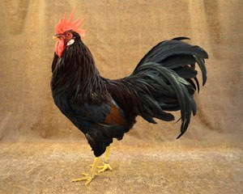

Production

The Leghorn is primarily a layer. The hen lays around 200 or more eggs per year. (The Best Egg-Layer)Leghorns are good layers of white eggs, laying an average of 280 per year and sometimes reaching 300–320.

A Leghorn chicken will lay for about 4-6 years and lay 280 eggs per year. A hybrid chicken will lay for 2-3 years and will lay about 300 eggs per year.

Better egg layer than brooder.

Pricing of Leghorns

|  |  |  |
| --- | --- | --- |
| **Sex** | **1-5** | **15-24** |
| Straight Run | $3.35 | $3.20 |
| **Male** | **$2.56** | **$2.49** |
| **Female** | **$4.06** | **$3.91** |

All Leghorn varieties lay a large white eggs that weighs around 2 ounces. It is common for the already large egg to get larger as the chicken ages. Depending on the variety of Leghorns lay between 150 to 320 large eggs in a year.

They have a very good feed to egg conversion ratio. On an average, each bird need around 125 grams of feed daily. But Leghorn chicken is not good for meat production.

Because of its lightness, the leghorn is not considered a viable meat producer. They also tend to avoid human contact and are nervous and flighty.

Leghorn chickens are very not only active but also efficient foragers. They are always willing to work, hunting and scratching. They are prolific layers and rarely go broody and are non-sitters (unless left undisturbed).

**Leghorn chicken Varieties:**

* Single Comb Dark Brown
* Single Comb Light Brown
* Rose Comb Dark Brown
* Rose Comb Light Brown
* Single Comb White
* Rose Comb White
* Single Comb Buff
* Rose Comb Buff
* Single Comb Black
* Single Comb Silver
* Single Comb Red
* Single Comb Black Tailed Red
* Single Comb Columbian

Single comb dark brown leghorn Single comb light brown leghorn

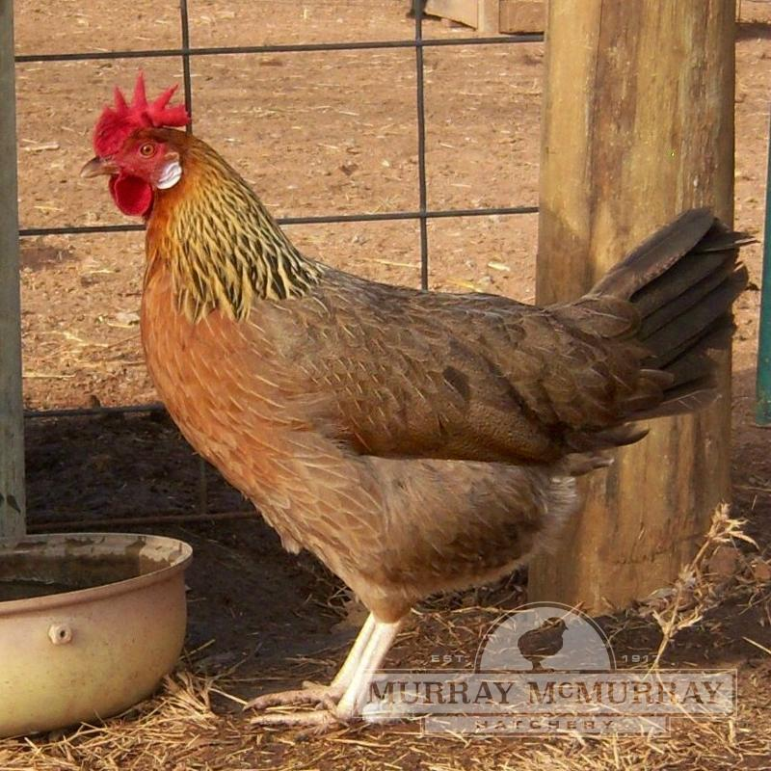 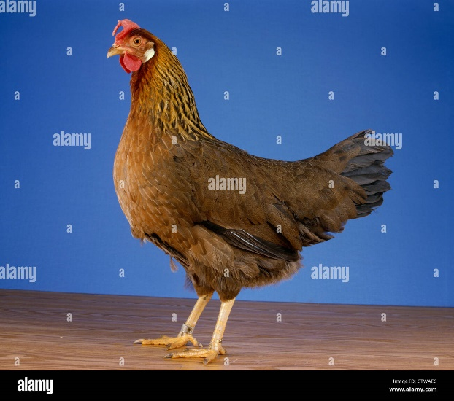

Rose Comb Dark Brown Single Comb White

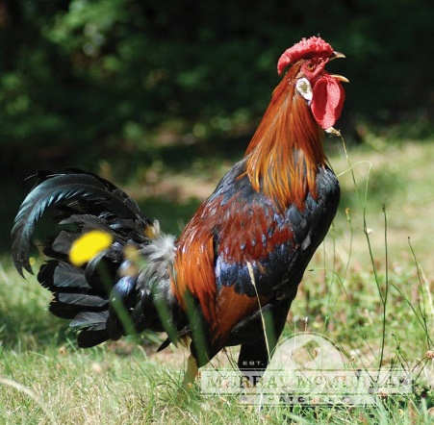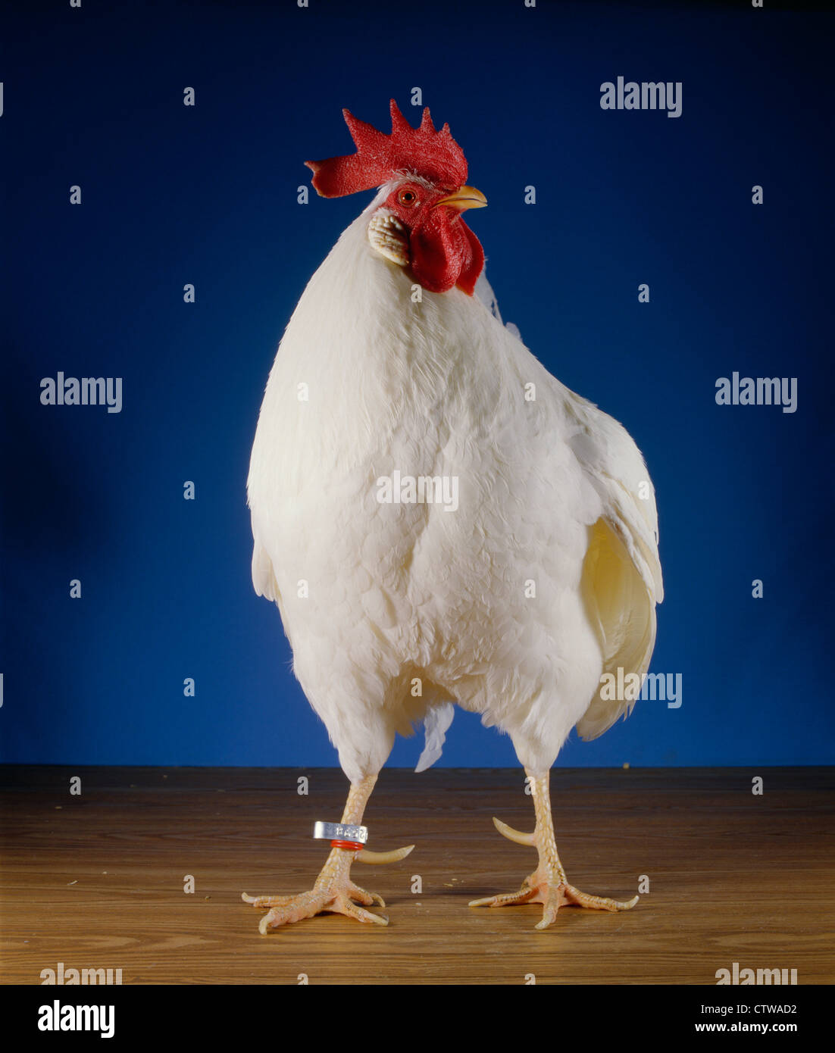

Rose Comb White Single Comb Buff

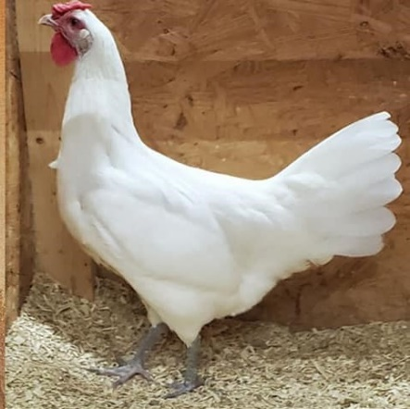 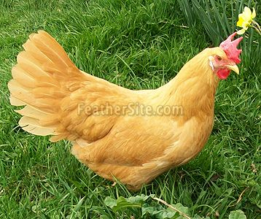

Rose Comb Buff

[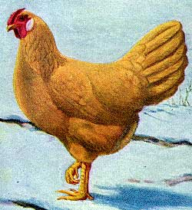](http://afs.okstate.edu/breeds/poultry/chickens/leghorn/buffros1.jpg)

**Leghorn Chicken Characteristics**

Ten color varieties are recognized in Italy, where the Livorno breed standard is recent. The Italiana is a separate Italian standard for the German Leghorn variety.

The French poultry federation divides the breed into four types. The American white, the English white, the old type (golden-salmon) and the modern type. And they listed 17 color variants for full-size birds and 14 for bantams.

The French poultry federation also recognizes an autosexing variety, the Cream Legbar. Both the American Bantam Association (ABA) and the American Poultry Association recognize numerous number of Leghorn varieties.

Fully grown Leghorn roosters weigh 3.4 kg, hens 2.5 kg, cockerels weigh 2.7–2.95 kg and pullets 2–2.25 kg and for the bantams variety the maximum weight is 1.02 kg for the roosters and 0.91 kg for hens (according to the British standard). But the Italian standard gives a weight range of 2.4–2.7 kg for roosters, 2.0–2.3 kg for hens.

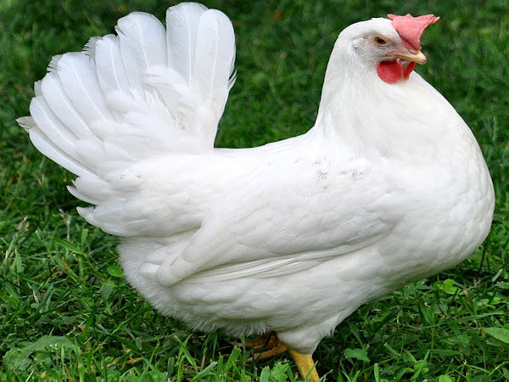

**Behavior/Temperament**

|  |  |
| --- | --- |
| Breed Name | Leghorn |
| Other Name | None |
| Breed Purpose | Egg Layer |
|  |  |
|  |  |
| Broodiness | Seldom |
| Comb | Single Comb |
| Climate Tolerance | All Climates |
| Egg Color | White |
| Egg Size | Large |
| Egg Productivity | Very High |
| Feathered Legs | No |
| Rarity | White Leghorns are common other varieties are less common |
| Varieties | Barred, Black, Blue, Buff, Buff Columbian, Dark Brown, Exchequer, Light Brown, White, Silver |

**The Good**

* Beautiful
* Calm
* Curious
* Easy to raise chicks
* Eats very little
* Friendly
* Great forager
* Great Layers
* Grow very fast
* Lays large white eggs

**The Bad**

* Can be assertive
* Fighty
* Noisy
* Not broody and hens are not good mothers
* Not good for meat production

Varieties:

Large Fowl: Single Comb (Brown, White, Black, Buff, Columbian, Dark Brown, Light Brown) Rose Comb (Brown, White, Light, Dark) Red-Tailed Red, Black-Tailed Red

Bantam: Black, Dark Brown, Silver, Buff, Light Brown, White

leghorn-chicken

Temperament: Active. Females are non-sitters.

Weight:

Large Fowl Size: Rooster, 6 pounds; Cockerel, 5 pounds; Hen, 4.5 pounds; Pullet, 4 pounds.

Bantam Size: Rooster, 26 ounces; Cockerel, 24 ounces; Hen, 22 ounces; Pullet, 20 ounces.

Fall 2010 032

Standard Description: Leghorn chickens comprise a group characterized by great activity, hardiness, and prolific egg-laying qualities. The females are non-sitters, very few of them exhibit a tendency to broodiness. Aside from the manifold points of beauty in type and color found in all varieties of Leghorn chickens as exhibition specimens, their excellent productive qualities are valuable assets of the breed. Breeders, exhibitors, and judges should pay regard to the Standard weight of Leghorn chickens.

Comb: Male: Single; fine in texture, of medium size, straight and upright, firm and even on head, having five distinct points, deeply serrated and extending well over the back of head with no tendency to follow the shape of the neck; smooth and free from twists, folds or excrescences. Rose; medium sire, square in front, firm and even on head, tapering evenly from front to rear and terminating in a well-developed spike that extends horizontally well back of the head; flat, free from hollow center and covered with small, rounded points.

Popular Use: Eggs, meat, and exhibition

Leghorn Chicken Owner Quotes:

“It is the most chicken-looking chicken.” — Ken Mainville, Backyard Poultry, August-September 2013.

“The Leghorn chicken is one of my favorite chicken breeds. I have had both White and Brown Leghorns. They are hardy, curious birds with tons of personality. They reliably produce large white eggs and are some of the best layers in my flock. When no one else is producing, my Leghorns are still going strong.” – Pam Freeman at Pam’s Backyard Chickens

Learn about other chicken breeds from Backyard Poultry, including Orpington chickens, Marans chickens, Wyandotte chickens, Olive Egger chickens (cross-breed), Ameraucana chickens and many more.

Promoted by: Fowl Play Products

The Leghorn has **red wattle, white earlobes, and has either a single or rose comb**. Leghorns go broody very rarely. These chickens have yellow legs and the eye is red all colors. The female chickens have a double folded comb, a deep abdomen, and a whipped tail.

**Pros:**

* Leghorns are able to withstand the cold due to their rose comb.
* This breed is known for its egg laying abilities.
* They will not go broody.
* Hens lay white eggs that get larger as they age.
* They are relatively high energy and love to forage.

Leghorn hens are very robust and adaptable.

They can tolerate both cold and hot climates and are self-reliant chickens.

Whilst they can tolerate the cold these chickens originally come from warm/temperate climate so this is where they do best and thrive. As with all poultry you will need to monitor for [parasites such as lice](https://naldc.nal.usda.gov/download/IND43893798/PDF), mites and worms.

You have the choice of treating on a regular basis or treating when you see a problem.

It is recommended that you **raise Leghorns away from other chickens** since the adolescent birds can be quite a handful until they settle down.

**Facts About This Breed**

1. The name Leghorn comes from port Livorno where it is thought this breed comes from.
2. Leghorns come in a variety of colors including: white, brown, black and buff.
3. Roosters weigh around eight pounds and hens about five pounds.
4. They eat a relatively small amount of feed because they prefer to forage for their own food.
5. These chickens are a fairly independent breed.
6. Because they are loud they are better placed in a home without close neighbours.

Production

Leghorn chickens are very active and efficient foragers. They are always willing to work, hunting and scratching. They are **prolific layers and rarely go broody and are non-sitters (unless left undisturbed)**. They lay throughout the year and eggs are white and are of good size

What do Leghorn chickens produce?

On average this hen will lay 4 large eggs each week, however the white variety can lay 5-6 eggs per week! Regardless of their plumage color they will all lay **white eggs**. These girls are early to mature but won't lay before 18-20 weeks

They originally come from Italy and were refined over the years – **they eventually became well known for their egg laying ability.**

In more recent times this breed has [excelled in backyards](https://www.chickensandmore.com/11-chicken-breeds-perfect-for-small-backyards/) and small homesteads.

Whilst each color variety of Leghorn Chicken will lay a good amount of eggs, it is the white Leghorn that is the superstar of the family.

She will lay for many years at the rate of 4-6 eggs each week.

Sadly this ability has been exploited and many of these beautiful birds spend their entire lives in cages or giant barns rarely seeing the light of day.

In small backyard flocks she is a great forager and loves nothing better than to spend the day searching for food and scratching in the dirt. They can also fly well and like to perch on high points and watch for predators.

Just remember if you would like to keep Leghorns you will [need plenty of space](https://www.chickensandmore.com/how-much-space-do-chickens-need/) for them.

They are not pet chickens and do not like being held – in fact they can get quite nervous around humans they do not know.

However overall she is a sweet hen once she is comfortable she will reward you with lots of beautiful white eggs.

The amount of eggs they lay will depend on their plumage color.

On average this hen will lay 4 large eggs each week, however the white variety can lay 5-6 eggs per week!

Regardless of their plumage color they will all lay white eggs.

These girls are early to mature but won’t lay before 18-20 weeks.

|  |  |
| --- | --- |
| **Egg Production** | |
| Eggs Per Week: | 4+ Eggs |
| Color: | White |
| Size: | Large |

|  |  |
| --- | --- |
| **Leghorn** | |
| Beginner Friendly: | No. |
| Lifespan: | 5+ years. |
| Weight: | Hens (5lb) Roosters (8lb). |
| Color: | White, brown, black and more. |
| Egg Production: | 4+ per week. |
| Egg Color: | White. |
| Known For Broodiness: | No. |
| Good With Children: | No. |
| Cost of Chicken: | $3+ per chick. |

